**CH 245: ORGANIC CHEMISTRY 1 LABORATORY (Fall 2019)**

**Title:**

1. **Purpose: (1 point)**

The purpose of this lab is to perform a simple distillation and a vacuum distillation on a mixture of hexane and decane to separate the mixture. This process allows us to separate liquids in a mixture based on different intramolecular forces and to purify liquids in a solution.

1. **Drawing of structure of the main compound or balanced chemical equation if synthesis is performed: (1 point)**

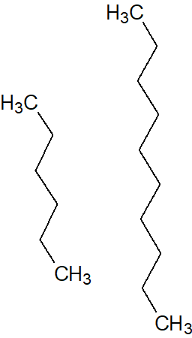

Hexane Decane

**3. Reagents and the major product (up to 6 points)**

|  |  |  |  |  |  |  |
| --- | --- | --- | --- | --- | --- | --- |
| **Name** | **M.W.**  (0.5 pts) | **Density**  (0.5 pts) | **Amount (grams/mL)**  (0.5 pts) | **Moles**  (0.5 pts) | **Hazards/Precautions**  **(MSDS data) and melting point or boiling point** (2 pts) | **Waste Disposal**  **(aqueous or organic)** (2 pts) |
| Hexane | 86.18 g/mol | 0.659 g/cm3 |  |  | Eye and skin irritation. BP: 69°C | Organic |
| Decane | 142.29 g/mol | 0.73 g/cm3 |  |  | Dryness on skin or eye irritation. BP: 172-174°C | Organic |

**4. Procedure (up to 2 points)**

|  |  |
| --- | --- |
| **Procedure** | **Observations and Lab Data** |
| A summary of the procedure done with bullet points) | Color changes, exothermic or endothermic reactions, gas generation, etc.; tare weights for flasks, etc. |
| * Place a 20-mL sample of the unknown hexane and decane mixture into a tared, clean, dry 50mL round-bottomed flask. * Record the mass of the mixture. * Set up the apparatus as shown on the demo table, with tared receiver flask. * Start distillation at atmospheric pressure. * Record the head temperature at short time intervals after the liquid starts to come over and starts condensing into receiver flask. * When the temperature begins to fall (or rise suddenly) and no more condensate is being collected, replace receiver with a second, tared 20 mL receiver flask. * Remove heat and cool. * Attach vacuum line and gradually turn vacuum to maximum. **Mixture must be at room temperature.** * Resume distillation while recording temperature of head at intervals. * Continue distilling to dryness. * Turn off heat, allow the apparatus to cool, and turn off vacuum. |  |

**5.** Results; include actual yield in grams and % yield.

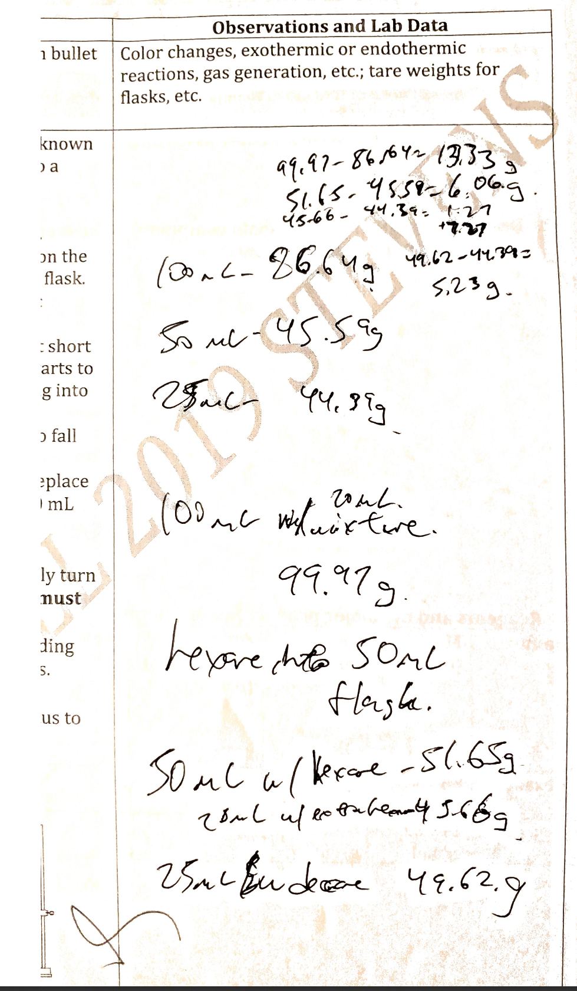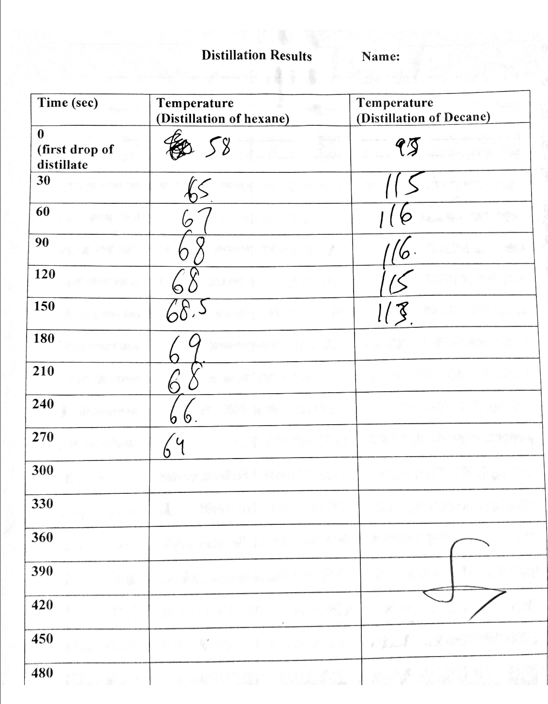

Weight of Hexane – 7.27 grams

Weight of Decane – 5.23 grams

|  |  |  |
| --- | --- | --- |
|  | Hexane | Decane |
| Weight | 7.27 grams | 5.23 grams |
| % Volume | 60.6% | 39.4% |
| % Mass | 58.2% | 41.8% |
| Mole fraction | 69.7% | 30.3% |

Volume of hexane = 7.27g * 1 cm3/0.659 cm3 = 11.03 mL

Volume of decane = 5.23g * 1 cm3/0.73 cm3 = 7.16 mL

Total volume = 18.19 mL

Moles of hexane = 7.27 grams / 86.18 g/mol = 0.0844 moles

Moles of decane = 5.23 grams / 142.29 g/mol = 0.0368 moles

Total moles = 0.121 moles

Boiling point of hexane – 68-69°C

Boiling point of decane – 116°C

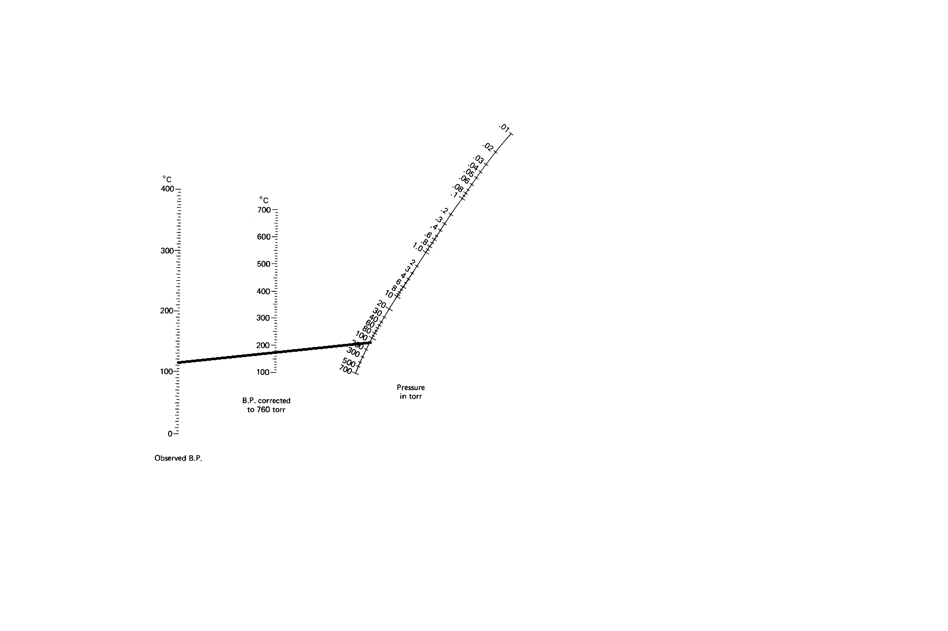

I estimate the vacuum pulled by the house vacuum to be about 130 torr.

**Conclusion:**

I **accomplished** a separation of decane and hexane in solution using two different types of distillation: simple distillation and vacuum distillation. I **learned** how to execute both methods of distillation, and learned not only about how two substances with a large enough difference in boiling point could be separated, but also about how useful a vacuum is when boiling substances to lower the amount of heat needed. One **issue** during the experiment was a lack of patience for the substance to cool enough before pulling the vacuum, resulting in a small amount of premature boiling, which may have caused some error. My **future recommendation** is to wait longer before pulling the vacuum, putting a thermometer in the solution to double check the temperature, or cooling the solution in an ice bath to speed up the process. The **practical application** of this lab is to separate two compounds with different boiling points, or to purify compounds in sensitive environments, such as drug making.